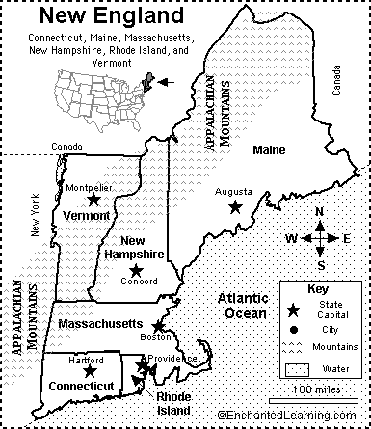
New England Map/Quiz Printout
1. In which part of the USA is New England located: northeast, northwest, southeast, or southwest? ________________________________
2. What country borders New England on the north? _______________________________
3. What US state borders New England on the west? _______________________________
4. What ocean borders New England on the east? _______________________________
5. What mountain range runs through much of New England? __________________________________
6. What state in New England is both the farthest north and east? ___________________________________
7. What state in New England is the farthest south and west? ____________________________________________
8. What is the name of the smallest state in New England? __________________________
9. What is the name of state in New England that has a long, curving cape that juts into the ocean? ______________________________________
10. What are the two New England states located west of Maine and east of New York? __________________________ and __________________________

